Continuous Assessment

CA4 Summary

Des McCann 10361637

B8IT105

27/11/2017

PART 1: Overall Summary

# Background:

* Data is taken from a web log file.

# Data Gathering:

* A python script has completed on the raw data, the raw data has been summarized into a CSV format.

# Data Visualization and conclusions:

* The CSV format has been loaded into SAS JMP to allow for data visualization and conclusions.

First observation that is apparent is that the majority (81%) of the 422 transactions completed were completed by 2 people Can see that Thomas is responsible for 45% of all transactions, while Jimmy is responsible for 36% of all transactions.

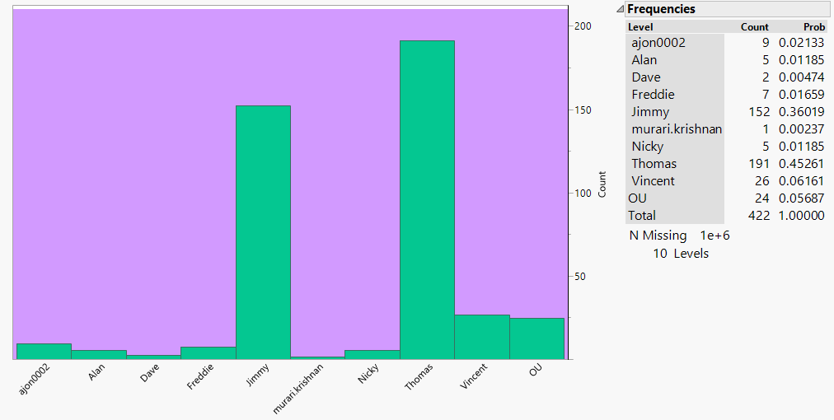

Same data represented in pareto plot (ordered with Cumulative probability shown on Y axis.)

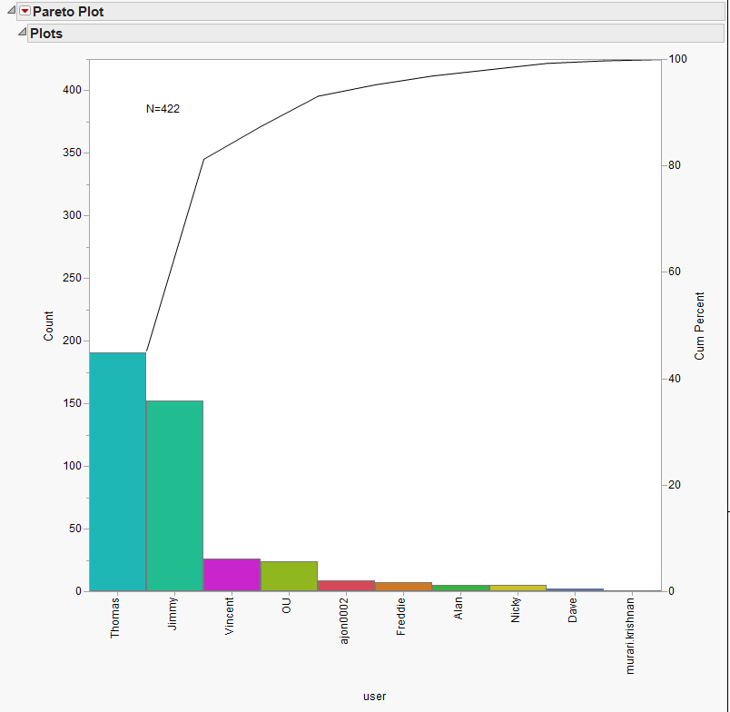

Second set of plots show that the modify work has continued fairly steadily through the year. The bulk of the Deletions occurred early in the dataset, while the ADD’s have occurred mainly in the 2nd half of the dataset. Can also see that MODIFY is the most common event

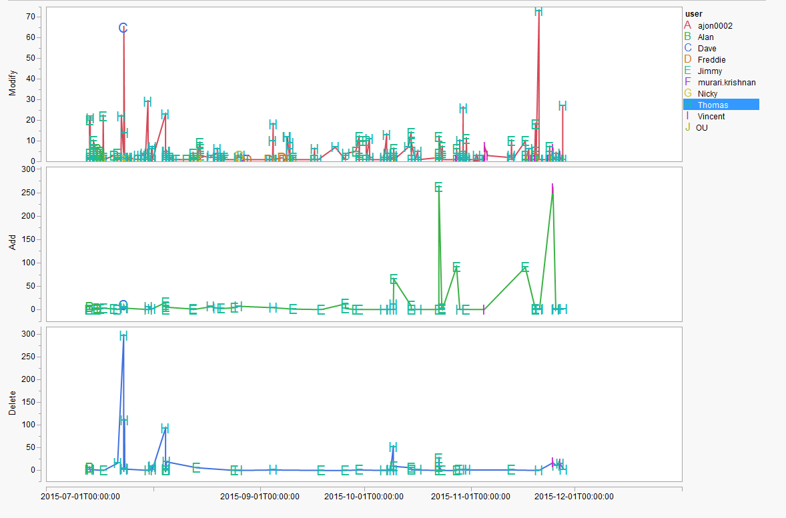

Can see below that the dominant activity is the Modify while the least common action is deletions. (note that some transactions have more than one action occurring and this explains why you have more than 422 entries.)

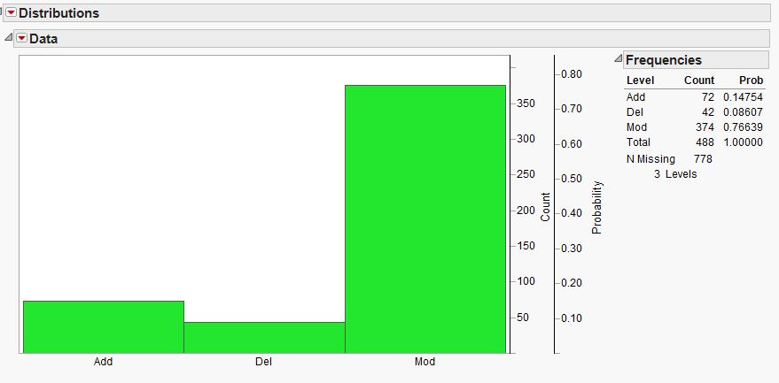

Finally to understand who is the most dominant user for each type for transaction.

Modify: All users making modifications. Thomas and Jimmy account for the majority of modify transactions.

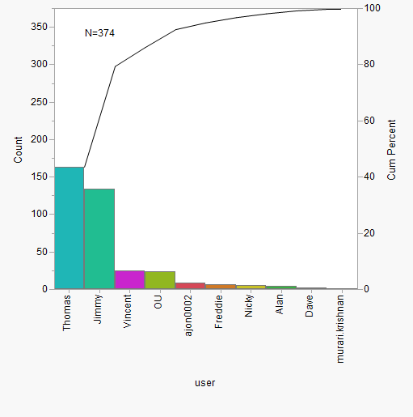

Delete: More than 50% of delete events completed by Thomas. Only 4 individuals have completed delete events.

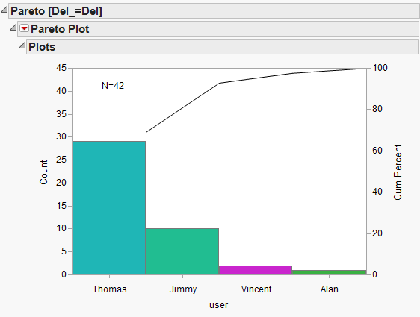

Add: Jimmy and Thomas making the majority of events. Only 5 users ( the same 4 completing deletes + Dave)

